LocalDB - the local database alternative where the database is 2 files on the same machine as your project.

Server=(localdb)\mssqllocaldb  
This "piggy backs" or "hitches a ride" on your Windows Authentication   
so it does not need a Username and Password.

Use this as the backup method if we have any issues with a remote server.

In the case of starting with an sql file eg "Northwind.sql":

1. Start Microsoft SQL Server Management Studio
2. Connect to Server with:  
   Server name: (localdb)\mssqllocaldb  
   Authentication: Windows Authentication  
     
   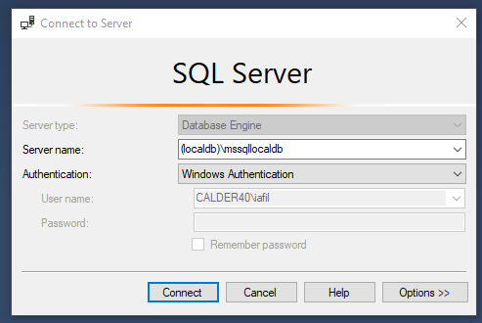
3. Create an empty database as you usually would.  
   You are not sharing your own machine with 60 other students (we hope!) so you can use a simple direct database name like "Northwind", "XSpy"
4. Double-click on the sql file, edit or write the USE statement at or near the beginning and load the database in the usual way.
5. In your app folder "appsettings.json" the connection string looks like this. You can copy and adapt this one.  
     
   "Server=(localdb)\\mssqllocaldb;Database=Northwind;Trusted_Connection=True;MultipleActiveResultSets=true"
6. For handins  
   You need to close Visual Studio and Microsoft SQL Server Management Studio  
   The Database takes the form of 2 files with filenames like "Northwind.mdf" and "Northwind_log.ldf"  
   These files are in "C:\Users\<your username>"  
   Copy and paste them into the container folder for your work before you zip it for hand-in.